* Webapps are basically websites
* Package and upload the code in azure and it will use your service plan to run the code.
* Code will only run on azure then someone will visit your website with the Webapp URL.
* To run code independently we use Webjobs. Its in the Webapp portal itself.
* WebJobs provide an easy way to run scripts or programs as background processes in the context of your app.
* 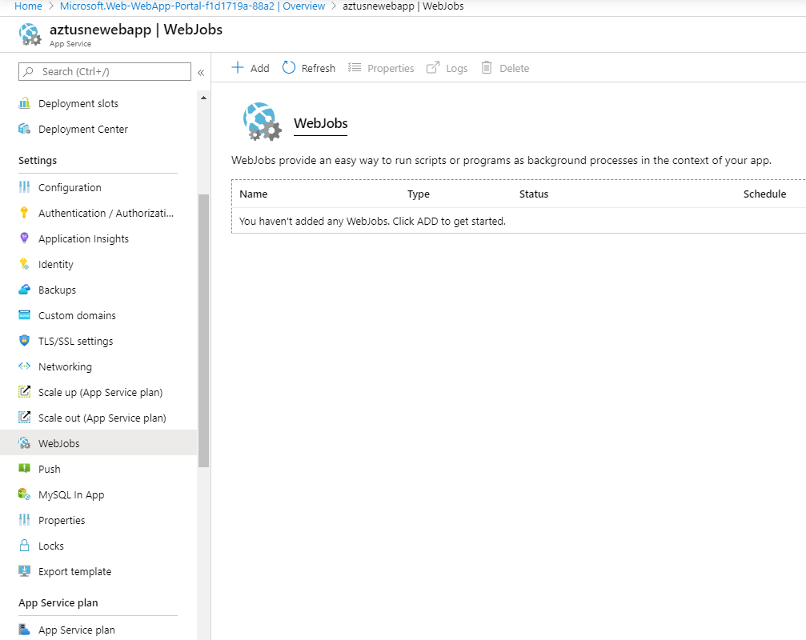
* Webjobs creation options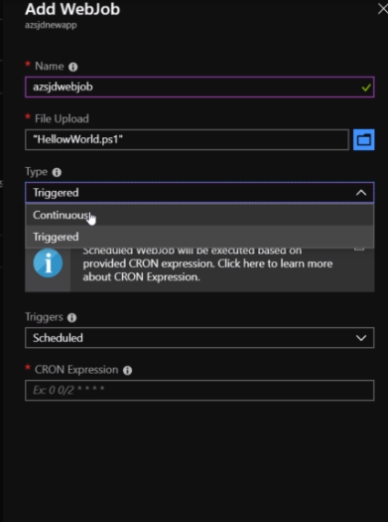
* Link to study about it <https://docs.microsoft.com/en-in/azure/app-service/webjobs-create#CreateScheduledCRON>
* Some resulting Cron expression can be used as per requirement for the app for Continuous Webjobs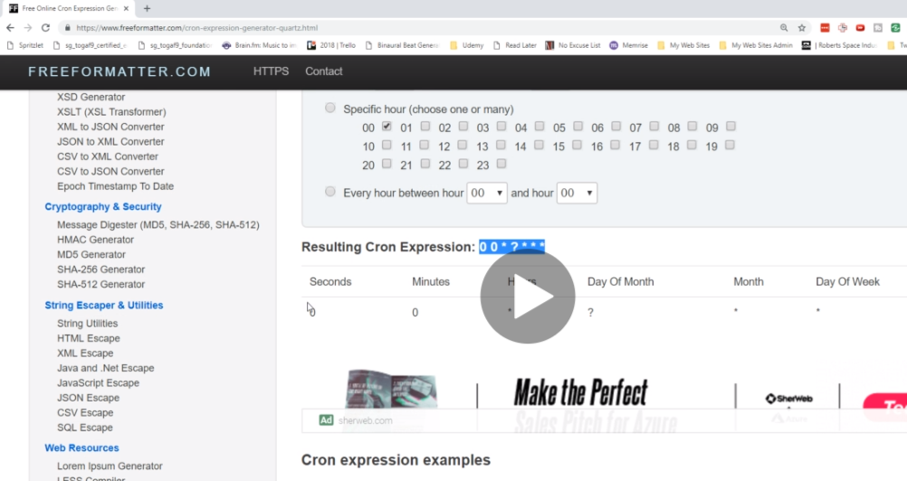
* Webjobs do not have UI by default. These jobs can be used to do some background jobs example latest calculation, move latest files or store latest data. 